9. FLOW THROUGH PIPE
LOSSES IN FLOW:
The energy sacrificed (Given Away) by a fluid in order to overcome resistance against the flow is known as loss.
TYPES OF LOSSES
MAJOR LOSS | MINOR LOSS
It’s caused by friction or by the virtue of wall shear stress. | Due to geometric change in the stream lines.
MAJOR LOSS:
- It’s caused due to Fluid friction/ Wall shear Stress.  - Darcy-Weisbach Equation is used for calculating loss. | $$h=\frac{fLV^{2}}{2gD}=\frac{fLQ^{2}}{12.1 D^{5}}$$
- For Different flow,  $$f={64}/{Re}(Laminar flow)$$ $$f=g(Re,Roughness)(Terbulent flow)$$ | $$h∝f∝τ_{0}$$
- Major head loss linearly increases with the length of pipe. | $$h∝L$$
- Influence of $V,Q,D$.
For laminar Flow | $$f={64}/{Re}$$ | $$h=\frac{32 μVL}{γD^{2}}∝V$$ | $$h=\frac{128 μQL}{γπD^{4}}∝Q$$ |  | $h \& D Relation$Depends on the Constant Condition ($V or Q$)
For Turbulent Flow | $$f=g(Re,ε)$$ | - For Relatively Smooth pipe $f=g\left(Re\right)$  - $Re$ is relatively law. $f=a{\left(Re\right)}^{-b}$ E.g. Blasius Equation. |  |  | $$h∝V^{2-b}D^{-\left(1+b\right)}$$  $$h∝Q^{2-b}D^{-5+b}$$  $$h \& D Depened on Q \& V$$
 | $$f=Const.$$ | - Rough pipe  - High $Re$ |  | $$h∝V^{2}D^{-1}$$ | $$h∝Q^{2}D^{-5}$$
 |  |  |  | $$h \& D Depened on Q \& V$$

FLOW THROUGH DUCT: A conduit having non circular cross section is known as duct. E.g. AC duct, Etc…
$$Re=\frac{ρVD_{h}}{μ}$$ | Characteristic Length of Flow/ Hydraulic Diameter: $D_{h}={4A}/P$ | NOTE: The working fluid through a pipe is mostly a liquid whereas the working fluid through a duct is mostly gaseous.
MINOR LOSSES: Losses in flow due to abrupt change in the geometry of flow are known as minor losses. It’s generally in the range of 5%-10% of major losses. E.g. Sudden Expansion/ Contraction, Bends, Fittings, Etc…
PHYSICS BEHIND MINOR LOSSES:
Real flow takes place from higher total head to lower total head. For boundary Stream lines, the total head is almost in the form of pressure head and flow should take place from higher pressure head to lower pressure head. For adverse pressure gradient minor losses takes place.
SUDDEN EXPANSION LOSSES:
From continuity equation, $A_{1}V_{1}=A_{2}V_{2}$  From momentum equation, $A_{1}P_{1}+P^{'}\left(A_{2}-A_{1}\right)-A_{2}P_{2}=∆\left(\dot{m}V_{x}\right)$  $$\frac{P_{1}-P_{2}}{ρg}=\frac{V_{2}^{2}-V_{1}V_{2}}{g}$$ $$Here, P^{'}≈P_{1} \&$$ $$∆\left(\dot{m}V_{x}\right)=ρA_{2}V_{2}$$  From Bernoulli’s equation,  $$h=\frac{P_{1}-P_{2}}{ρg}+\frac{V_{1}^{2}-V_{2}^{2}}{2g}⇒h=\frac{{\left(V_{1}-V_{2}\right)}^{2}}{2g}(From Previous Eq.)$$ | 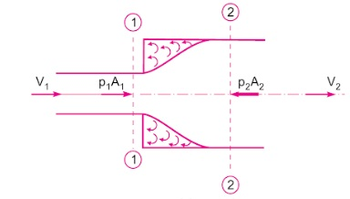
If Coefficient of loss is given directly use the formula.
$$EXIT LOSS:h=\frac{V_{1}^{2}}{2g} (∵V_{2}=0 for Exit Condition)$$ |  | $$h=K\frac{V_{1}^{2}}{2g}, Where K=Coefficient of Loss$$
SUDDEN CONTRACTION LOSS: $$h=\frac{{\left(V_{c}-V_{2}\right)}^{2}}{2g}=\frac{V_{2}^{2}}{2g}{\left(\frac{1}{C_{c}}-1\right)}^{2},$$  $$Where C_{c}=\frac{A_{c}}{A_{2}}=\frac{V_{2}}{V_{c}}$$ | 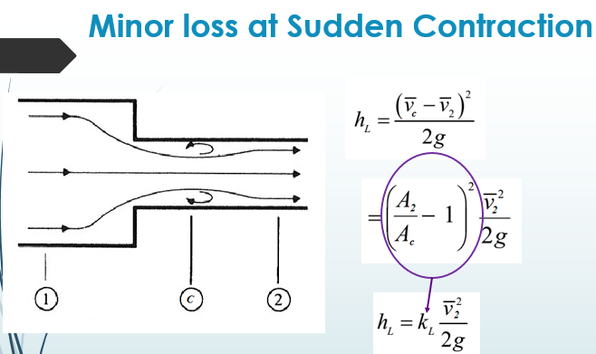 | ENTRY LOSS:  $$Here,{\left(\frac{1}{C_{c}}-1\right)}^{2}=0.5$$  $$h=0.5\frac{V_{2}^{2}}{2g}$$ | 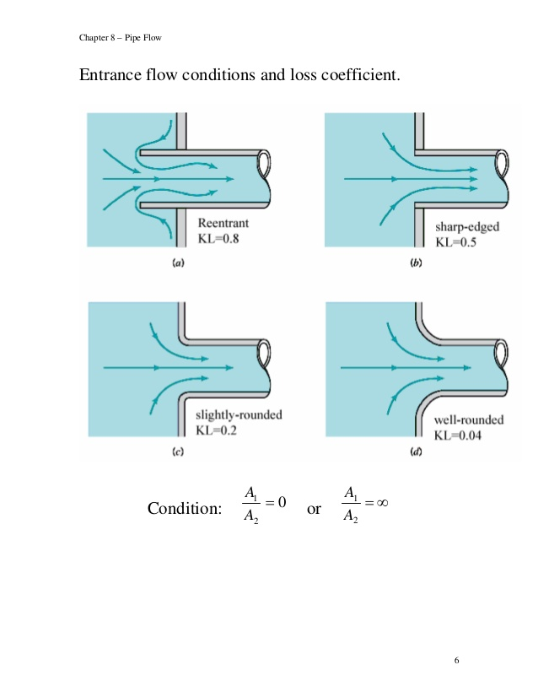
LOSSES IN BENDS & FITTINGS:  $$h=K\frac{V_{2}^{2}}{2g}$$ |  | 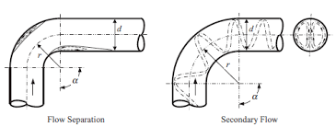

CONNECTIONS IN PIPE SYSTEM
SERIES CONNECTION | PARALLEL CONNECTION
ASSUMPTIONS:
- Minor Losses are neglected unless the problem specifies them to be considered.
- Flow is assumed to be turbulent.
EQUIVALENT PIPE:
A single pipe which can replace a system of pipes such that it creates the same discharge and head loss.
ANALYSIS OF PIPES IN SERIES: Discharges remains same.
Each Pipe have $L,D,f,V,Q,h,∆P,ε$  From continuity equation, $Q_{1}=Q_{2}=…=Q_{n}=Q_{eq}$  From Energy Balance, ${\left(∆P\right)}_{eq}={\left(∆P\right)}_{1}+{\left(∆P\right)}_{2}+…+{\left(∆P\right)}_{n}$  By converting into head, $h_{eq}=h_{1}+h_{2}+…+h_{n}$  $${\left(\frac{fL}{D^{5}}\right)}_{eq}=\sum{{\left(\frac{fL}{D^{5}}\right)}_{i}}(From Darcy Eq.)(For same "f" Eq. is Dupits Eq. )$$ | 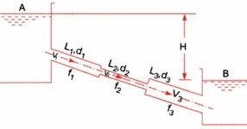
ANALYSIS OF PARALLEL CONNECTION: Head Loss remains same.
Each Pipe have $L,D,f,V,Q,h,∆P,ε$  From continuity equation, $Q_{eq}=Q_{1}+Q_{2}+…+Q_{n}$  From Energy Balance, ${\left(∆P\right)}_{eq}={\left(∆P\right)}_{1}={\left(∆P\right)}_{2}=…={\left(∆P\right)}_{n}$  By converting into head, $h_{eq}=h_{1}=h_{2}=…=h_{n}$ | 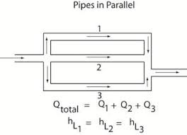

GRADE LINES
ENERGY GRADE/ TOTAL ENERGY LINE | HYDRAULIC GRADE LINE
The locus of total head throughout a flow. | The locus of piezometric head throughout a flow.
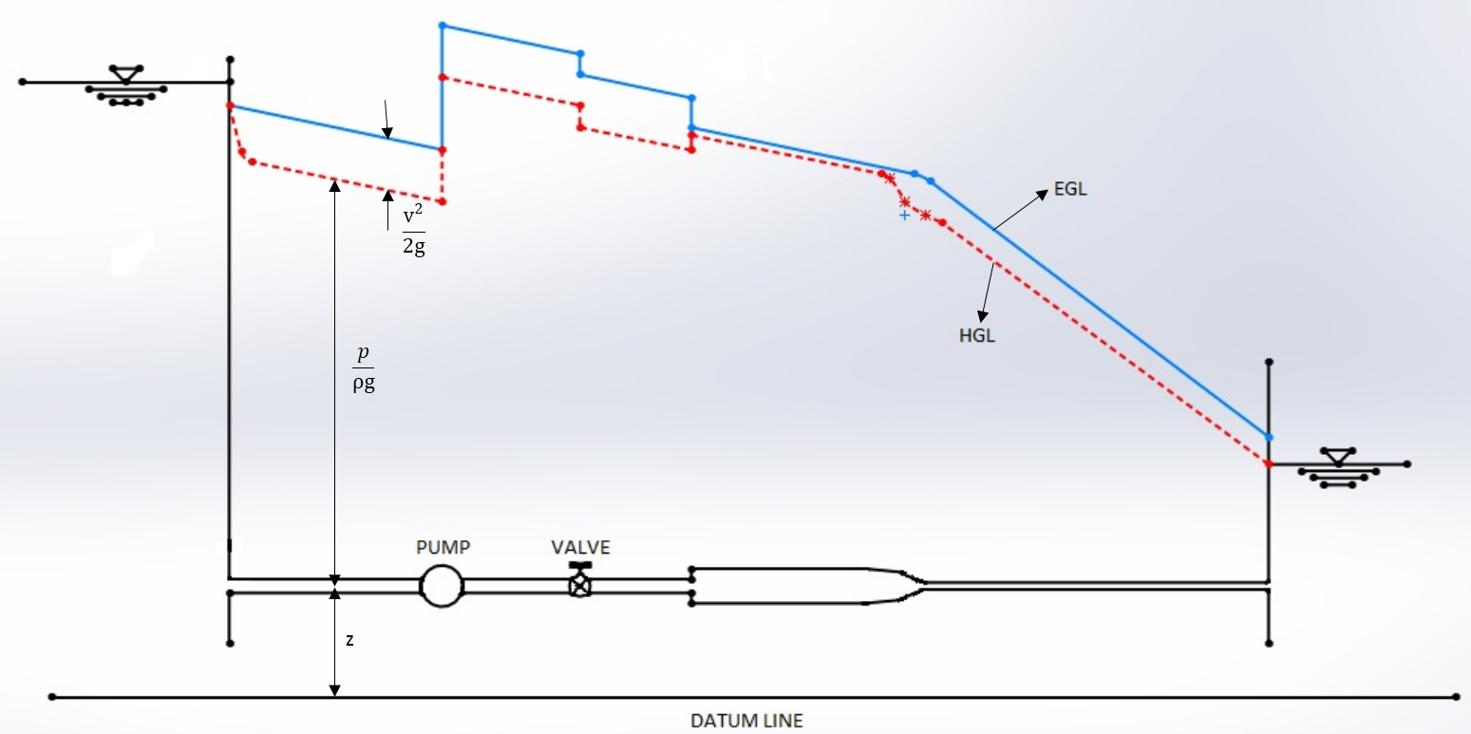
- The difference between EGL and HGL is velocity head.
- HGL is always below EGL except when velocity is Zero (HGL=EGL).
- HGL can move up or down. EGL moves down due to head loss or Turbine Work. EGL moves up only if a pump or external energy source is involved.
- In the case of a uniform diameter pipe, HGL and EGL must be parallel (Identical slopes).
- The slopes of HGL and EGL need not be dependent on the slope of axis of flow.
FLOW THROUGH SYPHON:  Flow Below HGL Flow Above HGL Flow on HGL  $$+ve P_{g}$$ $$-ve P_{g}$$ $$0 P_{g}$$  - Reducing the length of uphill pipe is favourable to overcome cavitation.  - If working fluid is water. $P_{v}=2.7m of water \left(abs\right)$  - If the height between HGL & Corresponding position in flow greater than $7.6 m$ of water, cavitation takes place. | 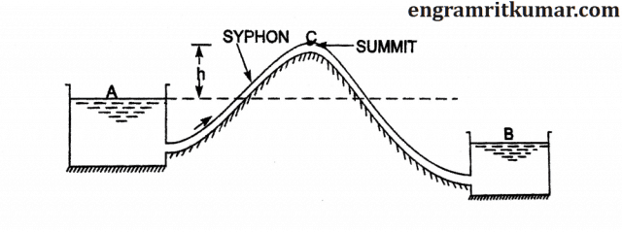
BRANCHING OF PIPES:
WORKING RULES:  - Flow takes place from higher $h^{*}$ to lower $h^{*}$.  - Minor losses are neglected.  - $Influx@ J=Efflux@J$  - $h_{A}^{*}>h_{J}^{*}; h_{B}^{*}>h_{J}^{*}⇒Q_{3} Towards R_{3} \& Q_{3}=Q_{1}+Q_{2}$  - $h_{A}^{*}<h_{J}^{*}; h_{B}^{*}<h_{J}^{*}⇒Q_{3} Towards J \& Q_{3}=Q_{1}+Q_{2}$  - $h_{A}^{*}>h_{J}^{*}; h_{B}^{*}<h_{J}^{*}⇒Q_{3}$  If $Q_{1}>Q_{2},Q_{3}$Towards $R_{3}$ $$Q_{3}=Q_{1}-Q_{2}$$ If $Q_{1}<Q_{2},Q_{3}$Towards $J$ $$Q_{3}=Q_{2}-Q_{1}$$  Now, Apply Bernoulli’s Equation between J and Other Point. | 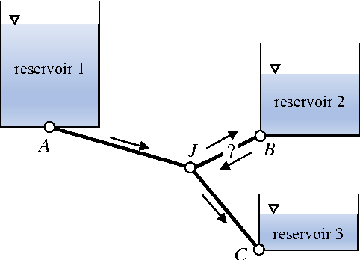
PIPE NETWORK:
Rule-I: Find $Influx@ Node=Efflux@Node$ For All nodes
Rule-II: Net Head loss in a loop is equal to zero. Give Any Clockwise and anticlockwise sign convention.
HYDRAULIC POWER: Power of the fluid available at the inlet of the turbine is called Hydraulic Power.
$$Ideal Head= Gross Head=H$$ $$Head Loss=h$$  $$Net Head=H-h$$  $$Efficiency=η=\frac{Net Head}{Gross Head}=1-\frac{h}{H}$$  Here,  $$P_{th}=P_{ideal}=HρgQ$$ $$P_{loss}=hρgQ$$  $$P_{act}=P_{net}=(H-h)ρgQ$$  CONDITION FOR MAXIMUM POWER:  $$P_{act}=f(Q,h)$$ From the Darcy Equation, $Q∝\sqrt{h}$  By differentiating w. r. t. $“h”$, $P_{act}$ is maximum at $H=3h$  $$η_{max}=66.666\%$$ | 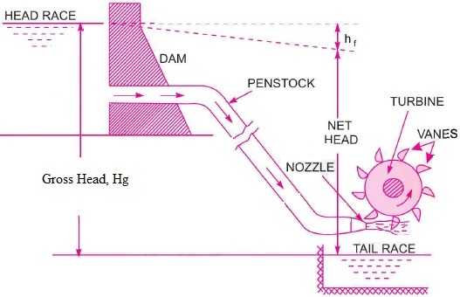
DIAMETER AT THE EXIT OF NOZZLE FOR MAXIMUM $P_{act}$:
By the Bernoulli’s Equation & Condition for Maximum Power & Darcy Equation, | $$H=\frac{V_{2}^{2}}{2g}+h=3h⇒\frac{V_{2}^{2}}{V^{2}}=\frac{2fL}{D}$$
By using Continuity Equation, $d^{2}V_{2}=D^{2}V$ | $$d^{4}= {D^{5}}/{\left(2fL\right)}$$
Where, $d,V_{2}=$ Diameter & Velocity of Jet | $D,V=$ Diameter & Velocity in the Pan Stoke

PUMPING POWER:  From the Bernoulli’s Eq., $H_{P}=H+h$  CASE-I: Ideal Pumping Power ($h=0$) $P_{P}= H_{P}ρgQ=HρgQ$  CASE-II: Actual Pumping Power $P_{P}= H_{P}ρgQ=(H+h) ρgQ$ | 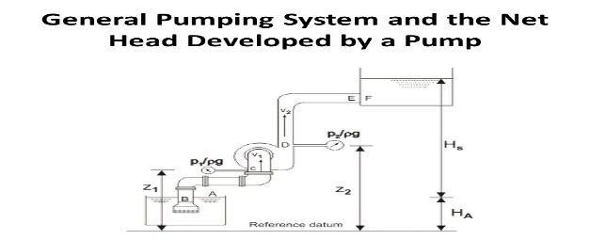
MISCELLANEOUS PROBLEMS
$$dh=\frac{1}{12.1}\frac{fQ^{2}dx}{D^{5}}$$ | $$D=D_{1}-\left(\frac{D_{1}-D_{2}}{L}\right)x$$
By integrating above equation from $x=0 to L$,
$$h=\frac{1}{12.1}*\frac{fLQ^{2}}{4\left(D_{1}-D_{2}\right)}*\left(\frac{1}{D_{2}^{4}}-\frac{1}{D_{1}^{4}}\right)$$
If the Flow takes in reverse direction, Above Formula can be used.
$$dh=\frac{1}{12.1}\frac{fQ^{2}dx}{D^{5}}$$ | $$Q^{'}=Q-qx$$
By integrating above equation from $x=0 to L$,
$$h=\left(1/3\right)h_{@Q=C}$$

WATER HAMMERING: When a valve is closed, then the sudden drop in KE creates compressible pressure wave propagating in the direction against the flow. The striking on the wall by this pressure is known as water hammer. It’s Examples of compressible fluid experience compressible flow. By using Surge Tank, we can avoid water hammering.
Here, Rise in Pressure $P=f(V,ρ,L,Bulk Modulus,E_{Pipe}, Speed of Valve Closing, Geomety of Pipe)$
CRITICAL TIME OF CLOSURE $\left(T_{C}\right)$:  The time taken by the pressure wave to propagate back & forth the length of penstock. | $$T_{C}=\frac{2L}{C},Where C=Acoustic Velocity=\sqrt{\frac{K}{ρ}}$$
ACTUAL TIME OF CLOSURE $\left(T_{a}\right)$: Actually, Time taken for closing time.

TYPE OF CLOSURE
GRADUAL CLOSURE |  | SUDDEN CLOSURE
$$T_{a}>T_{C}$$ |  | $$T_{a}≤T_{C}$$
$$F=ma=ρALV/{T_{a}}$$ |  | - Penstock is rigid (E is not given) |  | - Elastic Penstock (E is given)
$$P=ma=ρVL/{T_{a}}$$ |  | $$P=ρCV$$
 |  | $$C=\sqrt{K/ρ}$$ |  | $$C=\sqrt{{K_{eff}}/ρ},\frac{1}{K_{eff}}=\frac{1}{K_{fluid}}+\frac{D}{tE}$$
Where | $D=$Dia. of Penstock |  | $E=$Young’s Modulus of Penstock |  | $t=$Thickness of Penstock

